Working with MICAS Monitor

First you have to connect the serial line to the HW and to choose yor device:
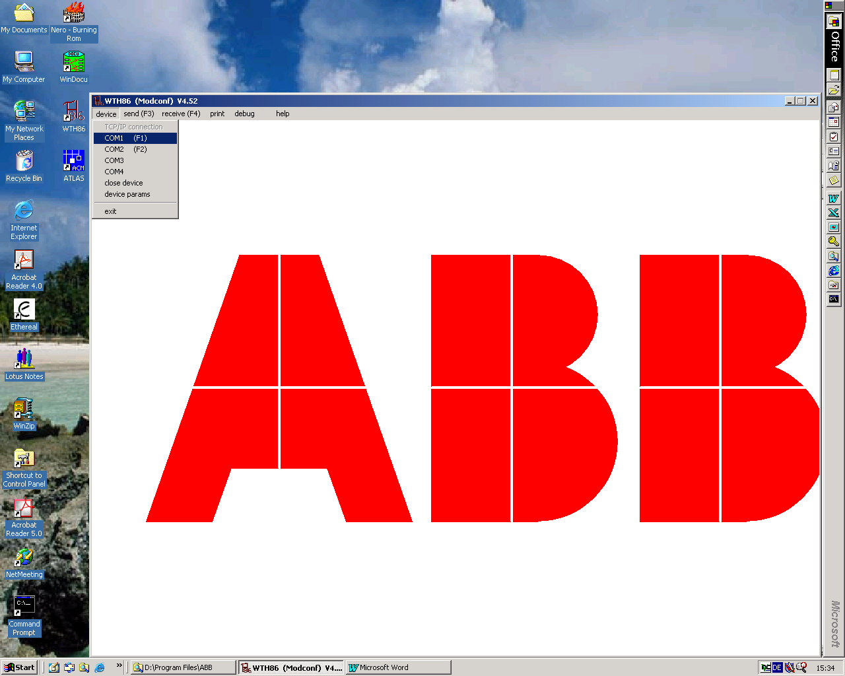
Device – COM1 or COM2

Next you can login to MICAS (either Ctrl-Shift C or @3*8=24) and you‘ll get the prompt: ‚*‘

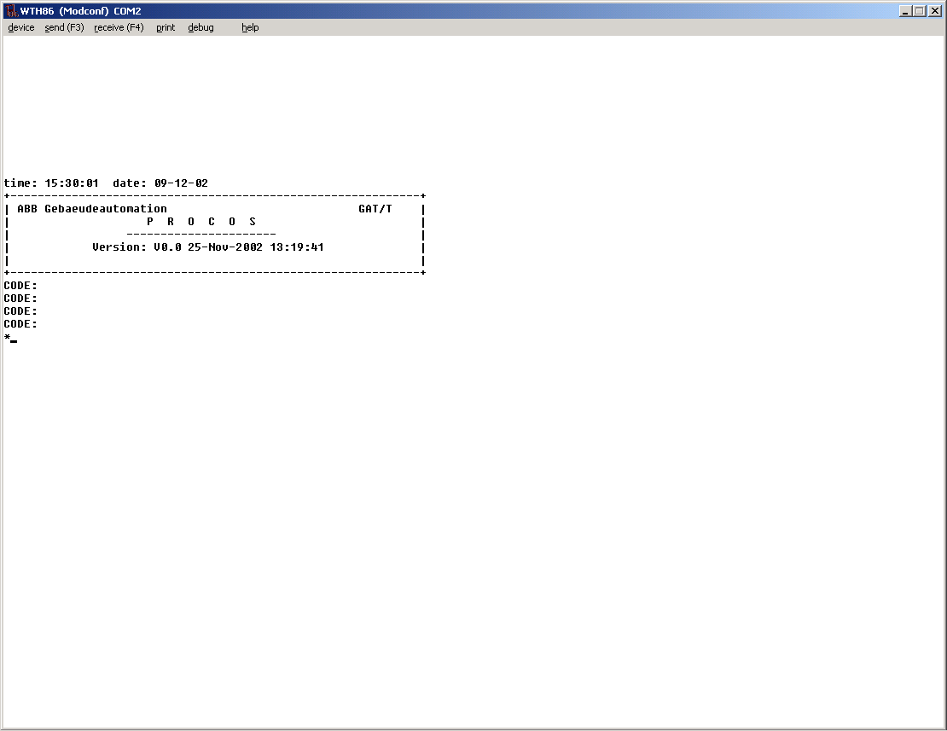
Prompt after login

Now you can display/change memory, load a task system or the data base, display and change configuration properties...

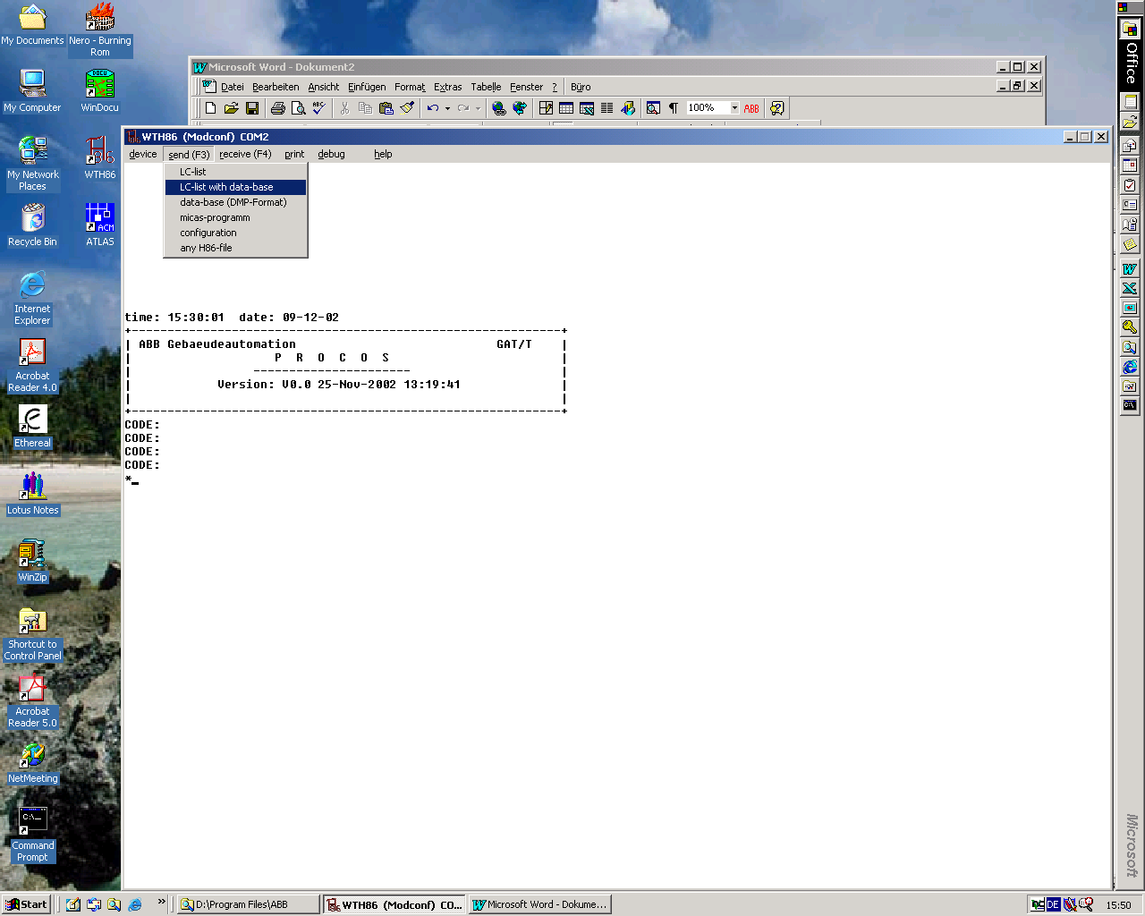
Load data base as file with extension *.h86
The data base generated by WinDocu can be found choosing the path \data\projekte\PROJECT_NAME\DBnUSnn02.H86 (W2000). This can be chosen in the dialogue and thus loaded.

After that a restart is necessary, do simply Q<CR> and you’ll get the message:
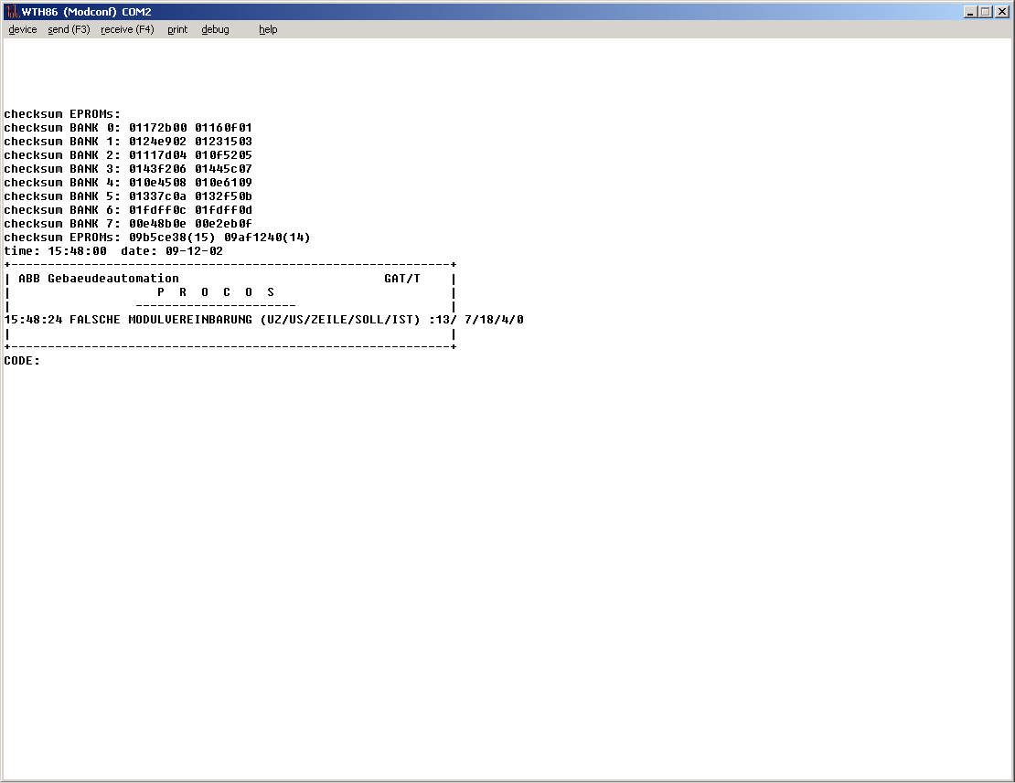
HW ZP20 restart

You can now login again. To see your ethernet interface type net -in
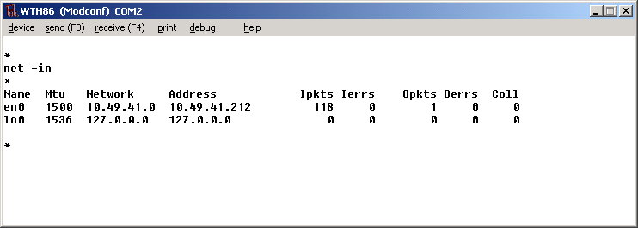
Ethernet Address with net mask

Note: there is no DHCP server to auto conf the interface, it is written into the EEPROM.
But you can change it by the SE .. command.
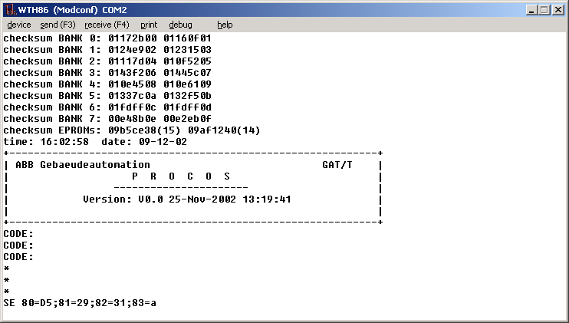
This command will change the interface’s addr to 10.49.41.213

The subnet mask can also be changed but in a limited manner. Only the host part is influenced and in the case of a class a net only the first two bytes of it, the last cannot be subdivided.
Let’s see how it works.
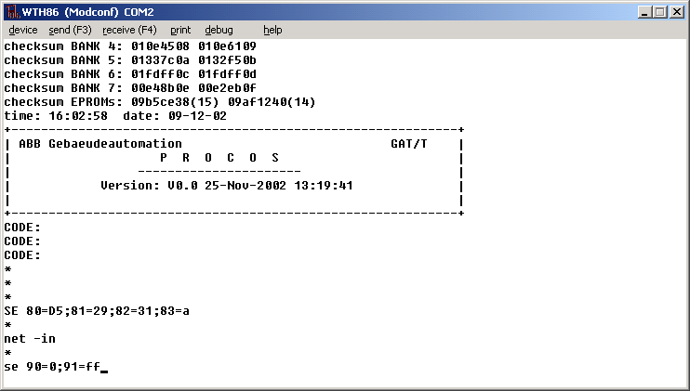
Subnet is set to 255.255.0.0 as can be seen

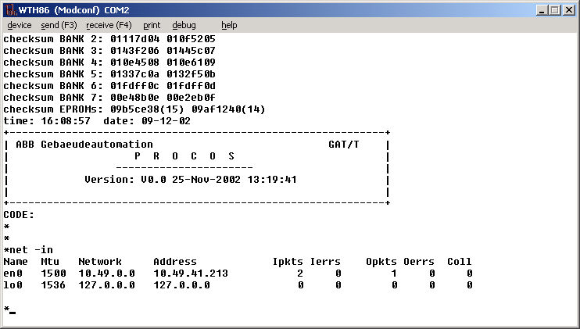
SE 90=ff;91=ff will set the subnet to 255.255.255.0 the Network in the ex. to 10.49.41.0

Changing the type of protocol
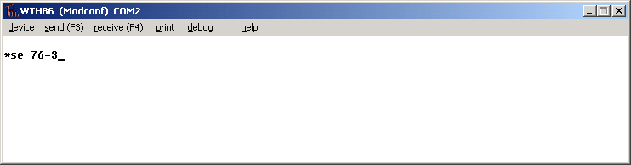
The areadat protocol can also be switched from Type II (contains Type I) to Type III and inverse by a parameter in the EEPROM. SE 76=3 switches to Type II and SE 76=1 switches to Type III. If the HW 29DI20 is plugged in the areadat protocol works with it otherwise it works with UDP on port 20028 and the substation sends theirs data grams back to the receiving port.

